Introduction to Computer Graphics
Computer Graphics (CG) is the field of computer science that focuses on creating, manipulating, and displaying visual content using computational techniques. It involves generating and processing images, animations, and visual effects for various applications like gaming, simulations, user interfaces, and digital art.

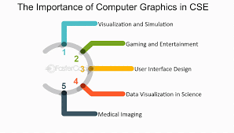
Fig, Importance and Application of Computer Graphics

Types of Computer Graphics

1. Raster Graphics (Bitmap)
Computer graphics can be broadly classified into Raster Graphics (Bitmap) and Vector Graphics. Raster graphics, also known as bitmap images, are composed of a grid of pixels where each pixel represents a specific color. These images have a fixed resolution, meaning they lose quality when scaled. Common raster image formats include JPEG, PNG, and BMP, and they are widely used in photographs, digital screens, and image processing applications.
2. Vector Graphics
Vector Graphics are based on mathematical formulas that define shapes such as lines, curves, and polygons. Unlike raster graphics, vector images can be scaled indefinitely without losing quality, making them ideal for applications that require precision and flexibility. They are commonly used in logos, Computer-Aided Design (CAD), animations, and illustrations where scalability and clarity are essential.
Algorithms Used:
1. Line Drawing Algorithm (Bresenham’s Line Algorithm)
- Used for drawing raindrops as vertical lines (line(x, y, x, y + 10);).
Steps:
- Initialize starting point (x1, y1).
- Compute the difference between endpoints (dx = x2 - x1, dy = y2 - y1).
- Calculate the decision parameter p = 2dy - dx.
- Plot the first point (x1, y1).
- Iterate until (x2, y2) is reached:
  - If p < 0, move right.
  - Else, move diagonally up-right.
  - Update p accordingly.
Used in: line(x, y, x, y + 10); (to draw raindrops).

2. Ellipse Drawing Algorithm (Midpoint Ellipse Algorithm)
- Used for clouds and tree leaves (fillellipse() and ellipse()).
Steps:
- Set the center of the ellipse (h, k).
- Initialize region 1 with:
  - p1 = b^2 - a^2*b + 0.25*a^2
- Iterate using:
  - x = x + 1
  - If p1 < 0, update p1.
  - Else, update p1 and decrease y.
- Transition to region 2 and use:
  - p2 = b^2(x + 0.5)^2 + a^2(y - 1)^2 - a^2b^2
- Stop when the entire ellipse is drawn.
Used in: fillellipse() (to draw clouds and tree leaves).

3. Flood Fill Algorithm
- Used for color filling various shapes like the tree trunk, house, and windows (floodfill()).

Steps:
- Select a starting pixel (x, y).
- Check if it matches the target color.
- If yes, change the color.
- Recursively apply the same process to adjacent pixels.
- Stop when all pixels are filled.
Used in: floodfill(215, 350, BROWN); (to fill tree, house, and window colors).

Functions Used:

1. initgraph()
Syntax:
void initgraph(int *graphdriver, int *graphmode, char *pathtodriver);
Purpose:
- Initializes the graphics mode for drawing.
- graphdriver = DETECT lets the system automatically detect the best driver.
- graphmode selects the appropriate mode.
- The third parameter (empty "") is used in modern compilers as it’s not needed.
Used in:
int gd = DETECT, gm;
initgraph(&gd, &gm, "");

2. cleardevice()
Syntax:
void cleardevice();
Purpose:
- Clears the screen before redrawing to create animation.
- Helps in refreshing the scene.
Used in:
cleardevice();

3. setfillstyle()
Syntax:
void setfillstyle(int pattern, int color);
Purpose:
- Sets the fill style and color for shapes.
- pattern: SOLID_FILL for solid colors.
- color: Color from predefined constants like LIGHTBLUE, BROWN, etc.
Used in:
setfillstyle(SOLID_FILL, LIGHTBLUE);

4. bar()
Syntax:
void bar(int left, int top, int right, int bottom);
Purpose:
- Draws a filled rectangle.
- (left, top): Top-left corner.
- (right, bottom): Bottom-right corner.
Used in:
bar(0, 0, getmaxx(), getmaxy());
bar(500, 300, 700, 500);

5. fillellipse()
Syntax:
void fillellipse(int x, int y, int xradius, int yradius);
Purpose:
- Draws and fills an ellipse at (x, y).
- xradius and yradius define the size.
Used in:
fillellipse(150, 40, 70, 40);

6. rectangle()
Syntax:
void rectangle(int left, int top, int right, int bottom);
Purpose:
- Draws a rectangle using top-left and bottom-right coordinates.
Used in:
rectangle(200, 300, 230, 500); // Tree trunk

7. ellipse()

Syntax:
void ellipse(int x, int y, int start_angle, int end_angle, int xradius, int yradius);
Purpose:
- Draws an ellipse at (x, y).
- start_angle to end_angle defines the section of the ellipse.
Used in:
ellipse(215, 250, 0, 360, 80, 100); // Tree top

8. floodfill()

Syntax:
void floodfill(int x, int y, int border_color);
Purpose:
- Fills a closed shape with the current fill color.
- (x, y): Inside the shape.
- border_color: The boundary color of the shape.
Used in:
floodfill(215, 350, BROWN); // Filling the tree trunk

9. line()
Syntax:
void line(int x1, int y1, int x2, int y2);
Purpose:
- Draws a line from (x1, y1) to (x2, y2).
Used in:
line(x, y, x, y + 10); // Raindrop
line(450, 300, 600, 150); // House roof

10. setcolor()
Syntax:
void setcolor(int color);
Purpose:
- Sets the current drawing color.
Used in:
setcolor(WHITE); // Rain

11. delay()
Syntax:
void delay(int milliseconds);
Purpose:
- Pauses the program for a specified time (in milliseconds).
- Used for animation.
Used in:
delay(50);

12. getmaxx() and getmaxy()
Syntax:
int getmaxx();
int getmaxy();
Purpose:
- Returns the maximum width (x) and height (y) of the screen.
Used in:
int x = rand() % getmaxx();
int y = rand() % getmaxy();

13. rand() and srand()
Syntax:
int rand();
void srand(unsigned int seed);
Purpose:
- rand(): Generates a random number.
- srand(time(NULL)): Initializes the random number generator.
Used in:
srand(time(NULL)); // Initialize randomness
rand() % getmaxx(); // Generate random x-coordinate for rain

14. while (!kbhit())
Syntax:
while (!kbhit()) {
// Loop continuously until a key is pressed
}
Purpose:
- Runs the animation until a key is pressed.
Used in:
while (!kbhit()) {
cleardevice();
drawScene();
drawRain();
delay(50);
}

15. getch()
Syntax:
int getch();
Purpose:
- Waits for a key press before exiting.
Used in:
getch();

16. closegraph()
Syntax:
void closegraph();
Purpose:
- Closes the graphics mode and releases memory.
Used in:
closegraph();

Program Code:

#include <graphics.h>
#include <stdlib.h>
#include <time.h>
#include <dos.h>
#include <conio.h>
void drawScene()
{

setfillstyle(SOLID_FILL, LIGHTBLUE);
bar(0, 0, getmaxx(), getmaxy());

setfillstyle(SOLID_FILL, WHITE);
fillellipse(150, 40, 70, 40);
fillellipse(220, 40, 80, 50);
fillellipse(300, 40, 70, 40);

fillellipse(500, 40, 80, 50);
fillellipse(600, 40, 70, 40);
fillellipse(700, 40, 80, 50);

setfillstyle(SOLID_FILL, BROWN);
bar(0, 400, getmaxx(), getmaxy());

setcolor(BROWN);
rectangle(200, 300, 230, 500);
setfillstyle(SOLID_FILL, BROWN);
floodfill(215, 350, BROWN);

setcolor(GREEN);
ellipse(215, 250, 0, 360, 80, 100);
setfillstyle(SOLID_FILL, GREEN);
floodfill(215, 250, GREEN);

setfillstyle(SOLID_FILL, YELLOW);
bar(500, 300, 700, 500);
setfillstyle(SOLID_FILL, RED);
bar(450, 200, 750, 300);
line(450, 300, 600, 150);
line(600, 150, 750, 300);

setfillstyle(SOLID_FILL, BROWN);
bar(570, 400, 630, 500);

setfillstyle(SOLID_FILL, WHITE);
bar(620, 330, 720, 420);
setcolor(BLACK);
line(620, 375, 720, 375);
line(670, 330, 670, 420);
}

void drawRain() {
for (int i = 0; i < 100; i++) {
int x = rand() % getmaxx();
int y = rand() % getmaxy();
setcolor(WHITE);
line(x, y, x, y + 10);
}
}

int main() {
int gd = DETECT, gm;
initgraph(&gd, &gm, "");
srand(time(NULL));

while (!kbhit()) {
cleardevice();
drawScene();
drawRain();

delay(50);
}

getch();
closegraph();
return 0;
}

OUTPUT:

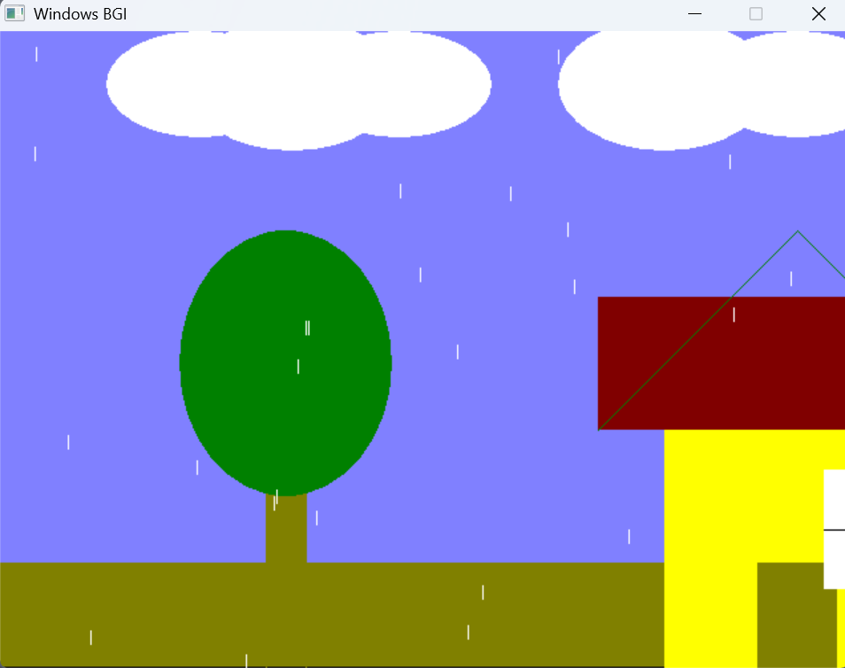

CONCLUSION

The rainfall simulation program effectively demonstrates basic computer graphics concepts using the graphics.h library. It creates a visually appealing scene with a sky, clouds, a tree, a house, and animated raindrops. By using functions like initgraph(), bar(), line(), and floodfill(), the program dynamically renders and updates the scene to create a continuous rainfall effect. Randomization ensures realistic raindrop placement, while the loop maintains smooth animation until user input is detected. This program serves as a fundamental example of 2D graphics programming and animation in C, helping beginners understand essential drawing and animation techniques in a structured way.

